**Media as 4th Pillar of Democracy**

News Journalism: Tracing its Evolution and a Case Study

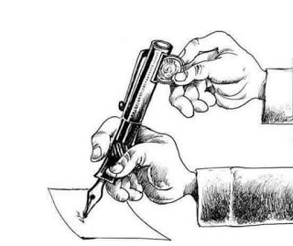

**News Journalism** - A deep dig into its evolution to its present state

Those rantings, news bulletins, weird catchy slogans and hot TV debates are no more an uncommon scene in today's world, particularly for an Indian household. We often find ourselves listening to TV debate-cum-shout with utmost interest while sitting on our dinner tables. The interest sometimes intensifies so much as if what valuable information is being extracted from those rants. Particularly in the Indian setting, News Journalism nowadays is characterized by 24*7 bulletins, media coverage of hot topics, shouts, and rants, scorching TV debates, heavy corporate and political influence etc. To set the environment for further work in this discussion, following key points shall be stressed: -

* Majority of the discussion shall be kept confined to the Indian setting.
* An attempt to trace the changes and trends in News Journalism over two or three decades shall be made.
* The discussion will highly focus on trends in National Large Media Houses. Local Media has not been talked about much for reasons of regional variations.

News Journalism – What this fuss is all about

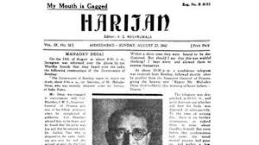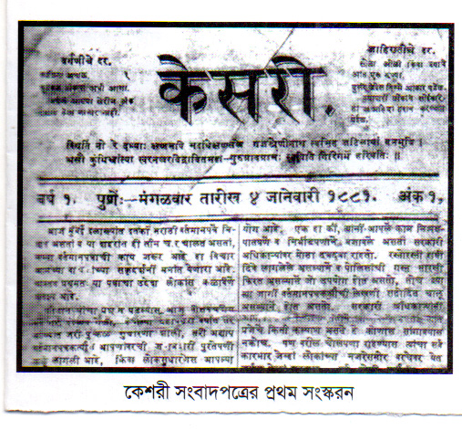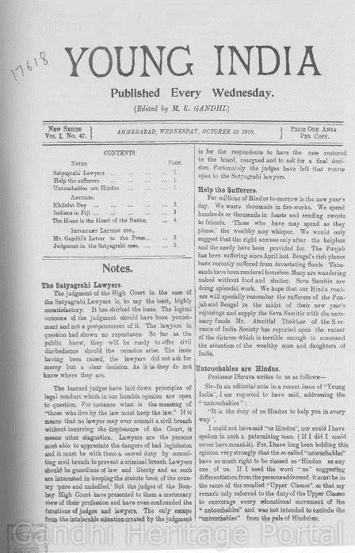Journalism is the act of collection of information regarding events happening around and then further conveying/ distribution to wider audience. When we say News Journalism, it specifically refers to a form where the person works to bring in information about events and which is then broadcasted as news. In India, Journalists have always attracted a lot of public attention and respect (at least in earlier times) in the society. Indian Constitution provides ‘**Right to freedom of Speech and Expression’** and thus free and fair journalism has been under work in India since independence. First official record of media functioning dates to 1780s when ‘**James Augustus Hicke**y’ published his ‘**Bengal Gazette’** [1]. During the British rule, initial newspapers were largely controlled by elite Britishers and served as a means for British Officials to be aware of happenings in the subcontinent. Later, many Indian counterparts came, some of them challenging the British rule while others politely putting forward the demands of oppressed Indian class. Many initial Newspapers were started by Indian revolutionaries and leaders such as Mahatma Gandhi’s ‘**Young India’** and **‘Harijan’**, Bal Gangadhar Tilak’s ‘**Kesari’**, Raja Ram Mohan Roy’s **‘Sambad Kaumudi’** [2] etc. But it is not so that journalism has only seen a flower bed since independence. During the ‘emergency’ of 1975, there was a major halt in press freedom when thousands of newspapers were confiscated, and journalists were detained. Nevertheless, these along with several other newspapers and later with the advent of radio and television subsequently bringing electronic media into the picture have always voiced the opinions of people to the government.

Emergence of new media in 21st century

At the time of Independence, there were 214 daily newspapers in India. At present there are more than 1 lakh newspapers and magazines currently published covering all the major languages. And 10 crore copies of them are printed every day. India is the largest newspaper market in the world. The number of channels showing 24-hour News in India is more than 400.[3] This huge boom in Media industry can be attributed to the following reasons:

* New developments in technology
* Rapid increase in popularity of TVs and radio when they were first introduced.
* Liberalization of Indian Economy in 1991 leading to more flow of information.
* In the recent times, Internet and connected technology has promoted rise of Electronic Print Media and Podcasts.

Today, almost all the media houses are owned by big corporates and giant businesses. A look at the following pictures shows the extent of corporate ownership of media in India.[4]

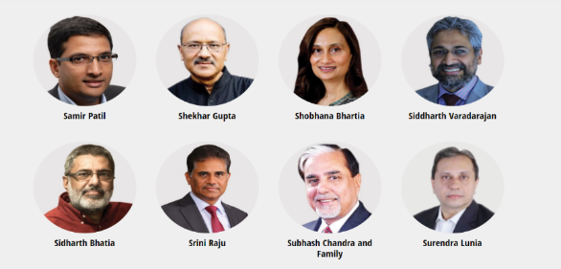

Recent trends in News Discourse

Today, Indian media is largely accused of partisanship. Though this sort of criticism has always been there and is not particular for Indian context. Wherever there is democracy, there is scope for public debate and thus, criticisms and questions arise naturally. Same is for India. But in the recent times due to advent of rapid technology and 24*7 media coverage, this trend of being biased is reflected at yet another level. Almost all the media houses have taken their sides. On almost all the issues that happen around in the subcontinent, people often get two broad viewpoints. One is that of so called ‘Right Wing media’ and the other is that of so called ‘Left Wing media’. A deeper analysis of these media groups tells us the reasons for such partisanship. All these media houses are owned by corporates either by individuals or as joint ventures. These corporates are associated with political funding to one or more political parties. To protect personal interests, these channels are thus influenced by corporates to favor one narrative over the other. Advertisements are another major reason for ‘biasness’ in media. By taking advertisements, media houses again associate themselves with personal interests of big corporates. The right-wing media usually favors ‘**the RSS influenced BJP and its associates’** and left-wing media usually sides with ‘**Indian National Congress (INC), Aam Admi Party (AAP), Communist Party of India** etc.’. It is worth noting that the term of left-wing media and right-wing media are not in strict sense and based on popular notions in India. For example, these partisanships are highly Religion bound as majority of the national right wing media sides with BJP and RSS ideology (right wing ideology rallying around Hindutva) while they are highly critical of AIMIM (also a right-wing party but its politics revolves around Islam.) Apart from this religion-based partisanship, Indian media is also highly criticized for its fake reporting on several matters in the past. To create headline and stir the environment, many a times unverified facts are presented to public. In recent times, a concept of ‘Hot-Debates’ has emerged where spokespersons of different parties come and debate on an issue. But these debates are highly unregulated, shouts and vulgarity are a common scene in these and many-a-times, anchors themselves cross all limits. Another trend that has emerged recently is that of ‘Discrediting those who question’. It’s not a common scene to see anchors using inadmissible terms such as ‘Tukde-Tukde (टुकड़े-टुकड़े) Gang’, ‘Award Vaapsi (वापसी) Gang, Jihadi (जेहादी) etc.

Post-Truth condition and News Journalism – A case study

Democracies are characterized by their adversarial politics. There is always a scope of conflict in decisions and policy making. But Post-Truth becomes dominant when negligence to facts and figures becomes prominent. Post-Truth condition refers to circumstances or cases where instead of facts and data, emotion and personal beliefs become more prominent in shaping public opinion. This is on a rise in India in recent times particularly due to religious/faith-based reasons.

The case of Love-Jihad: Is it truly there?

The term ‘**Jihad**’ has become one of the most favorite of many news channels and newspapers recently. The term ‘Jihad’ refers to struggle/striving particularly for a noble aim. The term is highly A picture containing text
misinterpreted in modern times. The term is now-a-days associated with deliberate violence and propaganda which is not really what is stands for and to make people agree to inhumane nature of ‘Jihadis’, appeals to religious sentiments are made. A very prominent case in present times in India is that of ‘Love Jihad’. The term ‘Love Jihad’ is on a trend in India and surrounding reasons in recent years. It is said to be an act of ‘deceiving non-Muslim women into love with a Muslim man followed by marriage and religious conversions.’ It is widely regarded as an Islamophobic theory by critiques. The term first emerged in a case in Kerala in 2009 where there was reporting of mass scale conversions of Hindu women to Islam for reasons of love and marriage. Since then, this term is on a rise and a subject of massive public debates. Many political parties including BJP have based their politics around this issue and have significantly raised it in election for obvious reasons. Some also accuse of religious funding my Muslim organizations and scholars for carrying out Love Jihad in southern Asia. As natural, Islamic leaders have denied all accusations and cited Islamophobic and political reasons for accusations. The true scene of the act is still under public debate. Majority population agrees that such acts have definitely been done but their extent and motives are under question. Some people claim that it is all a part of Islamist propaganda to make India a Muslim nation while some, particularly Muslim leaders deny any such propaganda. A major population though agrees on the fact that such incidents have definitely been done in India, but religious funding is nowhere involved, and these are just criminal acts where the Law and judiciary must deal with the case and punish the guilty instead of communalizing the act. Here the nation faces a Post-Truth condition where political parties appeal to religious sentiment and incite tensions and a sense of fear of being wiped out among non-Muslims, particularly Hindus. Religious fears are used as a tool to convince people that Muslim world is trying to wipe out other religions from India and make it a Muslim Nation. Slogans such as ‘लड़ के लिया था पाकिस्तान, हस के लेंगे हिंदुस्तान’ are notoriously used to incite tensions and implant inter-community hatred. In these cases, common sense, facts, and logic become insignificant and all that remains is a sense of fear and filth in mind. Such way of politics is natural of many political parties of both the religions. Here no one religion is to be blamed. Politicians and their agents from both the religions have contributed to this ‘illogical term’ becoming so popular and simultaneously so misunderstood.

In the above-mentioned case, media plays a key role. Modern media has the power to shape public opinion through its bulletins and shows. When people find themselves surrounded by so much coverage and news, with each side giving its own version of incident, it becomes very difficult to have independent thought. In such a scenario, people develop inclination towards whichever side promotes its theory much, which is more hyped, and which stirs the public. And this is exactly major media houses are doing presently in India. In the above cases, many a times media itself appeal to emotional sentiments of public and when this happens on a massive scale repeatedly, people start accepting even false theories with no evidence. Issue that are to be covered by a particular media depends on which side they are, whose government is in the state, which religion/caste/class etc. is being affected by it and then further reporting is done on these factors.

References

[1] [2] Media of India. *Wikipedia.* [*Wikipedia*](https://en.wikipedia.org/wiki/Media_of_India#:~:text=The%20Indian%20media%20consists%20of,Radio%20broadcasting%20began%20in%201927.)

[3] DNA Web Team. (Nov 17, 2020) DNA Special: Evolution of Indian Media from pre-independent era to modern times. *DNA India.* [*DNA India*](https://www.dnaindia.com/india/report-dna-special-evolution-of-indian-media-from-pre-independent-era-to-present-times-2856859)

[4] Media Ownership Matters. *Media Ownership Monitor India.* [*MOMI-RSF*](http://india.mom-rsf.org/en/)

IMAGE References

[1] <http://bestofindiarestofindia.blogspot.com/2015/12/beloved-journalism-to-bloo-journalism.html>

[2] <https://theprint.in/opinion/as-mahatma-gandhi-turns-150-his-news-magazines-navjivan-and-young-india-turn-100/298484/>

[3] <https://en.wikipedia.org/wiki/Kesari_(newspaper)#/media/File:KESARI.jpg>

[4]<https://hi.wikipedia.org/wiki/%E0%A4%B9%E0%A4%B0%E0%A4%BF%E0%A4%9C%E0%A4%A8#/media/%E0%A4%9A%E0%A4%BF%E0%A4%A4%E0%A5%8D%E0%A4%B0:Harijan.png>

[5] <http://india.mom-rsf.org/en/owners/companies/>

[6] <http://india.mom-rsf.org/en/owners/companies/>

[7] <http://india.mom-rsf.org/en/owners/individual-owners/>

[8] <https://i0.wp.com/www.opindia.com/wp-content/uploads/2020/09/Love-Jihad-Image-35-17-09-2020.jpg?w=712&ssl=1>

**Indian Institute of Technology Kanpur**

**Divyanshu Gangwar | Sophomore**

**Department of Electrical Engineering | IIT Kanpur**

[**dvyanshu@iitk.ac.in**](mailto:dvyanshu@iitk.ac.in) **|** [**LinkedIn**](https://www.linkedin.com/in/divyanshugangwar/)